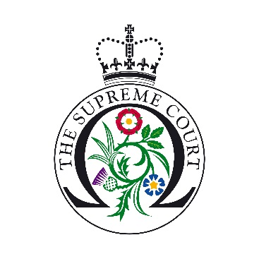

UK Supreme Court Student Writing Competition 2019/20 Entry Form

Name:
Year Group:
School:
Email address:
Contact number:
Address:

Where did you hear about the competition?
Please tick this box to confirm you are a UK Year 12 or Year 13 student (S5 or S6 in Scotland or Year 13 or 14 in Northern Ireland

