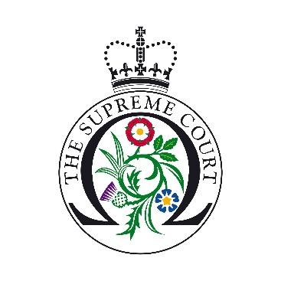

UK Supreme Court Moot Final Application Form
Please complete this form with the title ‘UKSC Moot Final application’ and email to enquiries@supremecourt.uk by 5pm Wednesday 1st of November 2023.

Name of Law School/Society
Click or tap here to enter text.

Contact details of moot organiser and a back-up contact, either deputy student or staff liaison. (name-position-email address-telephone number)
Click or tap here to enter text.

The Supreme Court Moot Final season runs from February-May. Slots are available between these dates on Mondays-Thursdays at 5-7pm.
Please specify dates that are not possible for your group (please take into consideration deadlines, exams and other university commitments)
Click or tap here to enter text.

Year group(s) and course of study of participants
Click or tap here to enter text.

Please give details of the number of students in your mooting competition and the number of previous rounds.
Click or tap here to enter text.

Would you like a tour before the moot? (for 30 minutes between 4-4:30pm on day of Moot, maximum 25 people. If you choose the virtual option, it can be on the same week).
Click or tap here to enter text.

Has your institution/society held a moot at the Supreme Court in previous years? If yes, please give dates.
Click or tap here to enter text.

☐Please tick to confirm that this is the only application from your law school.

☐Please tick this box to confirm that you have read, and fully agree to, the Supreme Court Moot Finals General Terms and Conditions.

☐Please tick this box to confirm that you would like your moot final to take place virtually.

