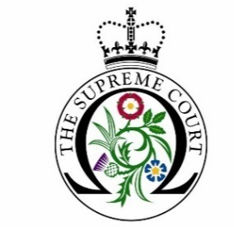

Debate Day Application Form

Name and address of educational institution:
Name and direct contact details of group organiser:
(please give your name, position, telephone number and email address). Please also provide details of another contact should we be unable to reach the group organiser.
What year group(s) will the participants be and what subjects/course(s) are they studying?
How many people will be in your group, including staff?
(please note we require a minimum of 15 students and an absolute maximum of 25)
The UKSC Debate Day Programme runs on selected Fridays between September - July (11am – 3pm). Unless you state otherwise we will assume you will be available on all the Debate Day dates listed on our website. Are they any specific dates or periods during this time when you are NOT available? Please take into consideration the exam period and other commitments.
Has your educational institution participated in a Debate Day workshop at the Supreme Court in previous years? If yes, please give dates.
Do you plan to bring your own lunches on the day or would you be happy for our caterers to send you details by email of options for lunches from the Supreme Court café?
Please tick this box to confirm that you have read and fully agree to the UKSC Debate Day Programme General Terms and Conditions.

