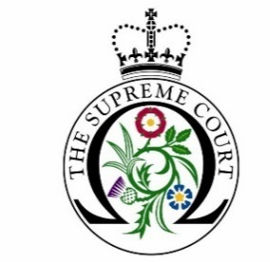

Debate Day Programme 2022-23

Application Form

Please read the accompanying terms and conditions before submitting this application form to enquiries@supremecourt.uk. The application deadline is 5pm on the 28th of September 2022.
Name and address of educational institution:
Status of your educational institution (i.e., state, grammar, independent, etc)
Name and direct contact details of group organiser:
(Name, position, telephone number and email address)
What year group(s) will the participants be and what subjects/course(s) are they studying?
How many people will be in your group, including staff?
(Please note we require a minimum of 11 students and an absolute maximum of 25)
Please state if you would like a physical or virtual session: (for the details of a virtual tour please see Terms and Conditions no. 9)
Debate Days take place on Fridays either 11 am – 3 pm or 2 pm - 5 pm. On this basis, please select three dates from the following available sessions. (We will aim to accommodate all selected schools; however, we cannot guarantee that you will receive the date of your choosing)
- Friday 4th November 2022
- Friday 25th November 2022
- Friday 9th December 2022
- Friday 13th January 2023
- Friday 27th January 2023
- Friday 24th February 2023
- Friday 10th March 2023
- Friday 6th May 2023
- Friday 26th May 2023
- Friday 9th June 2023

Has your educational institution participated in a Debate Day workshop at the Supreme Court in previous years? If yes, please give dates.
Please give any details of any widening participation schemes your school/college is involved in
Please give the Ofsted free school meals rating:
Lower than average
Average
Higher than average
Please tick this box to confirm that you have read and fully agree to the UKSC Debate Day Programme General Terms and Conditions.

