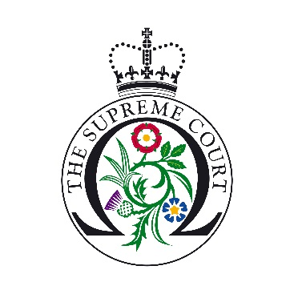

UK Supreme Court Ask a Justice Application Form
The Supreme Court is offering students the opportunity to have a live question and answer session with a Justice from their own classroom.
These sessions give students with a keen interest in law a unique chance to meet and speak with a Justice. Each session will offer 10 students the opportunity to speak for approximately three minutes with the Justice. The entire session will last no longer than 30 minutes/ 45 minutes
We will seek to prioritise schools and colleges from the wider UK: Northern Ireland, Scotland, Wales, North and South West of England.
Teacher’s Name
School
Year Group (Years 11-13 in England and Wales; Years 12-14 in Northern Ireland; S5 and S6 students in Scotland)
Email address
Contact number (Please provide a number so if anything goes wrong during the IT test or on the day of the session, it will be easy to contact you)
Address
Where did you hear about the programme?
Subjects studied by the students/their interests/career aspirations
100 words on how the school meets the criteria, why you would like to take part in the programme and how taking part will benefit the students
Name and number of IT manager at the School:
Can you use Skype, WebEx and/or Microsoft Teams?
YES NO
Please tick this box to confirm you have access to an Ethernet Cable
Please note that by ticking this box you are agreeing that you have the correct equipment to take part in the scheme. If WiFi is used during the IT test, we reserve the right to cancel your session.

Please see the educational resources available on our website (https://www.supremecourt.uk/learning-resources.html) in order to inform students about The Supreme Court and its role prior to the session.
The deadline for submission is 4th November 2020 at 5pm. Thank you for you application, candidates will be contacted during November 2020.

